Exam Three Sections
Multiple Choice: 30 points
- 15 questions at 2 points each
- 20 minutes

Sentence Revision 30 points
- 6 questions at 4 points each
- 15 minutes

Sentence Diagrams: 40 points
- 4 diagrams at 10 points each
- 30 minutes

Bonus Sentence Creation: 10 points
- 5 questions at 2 points each
- 10 minutes

Section A: Multiple Choice

Question One: Which of these best describes the aspect of the following sentence? (2 pts)
Sentence: I will have been playing bass for 25 years this winter.
Answer:_____
- Simple Aspect
- Progressive Aspect
- Perfect Progressive Aspect
- Perfect Aspect

Question Two: Which of these sentences is written in Past Perfect Progressive (Past Tense, Perfect Progressive Aspect)? (2 pts)
Answer:_____
- I have been working on a table.
- I had been working on a table.
- I was working on a table.
- I have worked on a table.

Question Three: Which of these sentences is in passive voice? (2 pts)
Answer:_____
- My paper was very long
- My paper was impressive to my peers.
- My paper was accepted for publication.
- My idea had been making me so frustrated.

Question Four: Which of these sentences correctly transforms the passive voice sentence below into active voice (while maintaining all other elements)? (2 pts)
Sentence: The payment had been accepted by the agent. (past – perfect)
Answer:_____
- The agent had been accepting the payments.
- The agent has been accepting the payments.
- The agent had accepted the payments.
- The agent accepted the payments.

Question Five: Which of the sentences below does NOT include a modal? (2 pts)
Answer:_____
- I do have the will to carry on.
- I must use all my strength.
- Victory shall be my reward.
- I can do it!

Question Six: Which of the sentences below does NOT include an auxiliary verb? (2 pts)
Answer:_____
- She does have an excellent point.
- Phong is being a real jerk.
- He has no excuse for his behavior.
- I simply will not be tolerating it any longer.

Section B:
Sentence Revision
Question Seven:
Revise this sentence by transforming it to Past Perfect (Past Tense, Perfect Aspect).
Sentence: I always am happy about my cooking. Present – Simple
Answer: I always had been happy about my cooking.

Question Eight:
Revise this sentence to change the voice from O to Passive. Maintain the original tense and aspect in the new sentence.
Sentence: The nurses are considering a new medication for Janet.
Answer: A new medication is being considered for Janet (by the nurses).

Active
The safety team had been evaluating all the products quite rigorously. – past, perfect progressive
All the products had been being evaluated quite rigorously by the safety team – Past, perfect progressive
All the products had been evaluated quite rigorously by the safety team – Past, perfect

Sentence Diagrams: 18 points (3 diagrams, 6 points each)
On the following pages, you will find three sentences. Each sentence is worth ten points.
Complete a diagram in the style we have been practicing. Please draw the diagrams by hand or using the digital tool on our Canvas page. I will grade generously, and I am not extremely concerned about the specific codes you use, so long as you label things clearly and structure the tree accurately. I am concerned that you draw the lines to the appropriate “level” on the diagram.
- Please be sure to include a node for each phrase (NP, VP, ADJP, ADVP, PP). When needed, please include an additional Clause (S) level to indicate sentences with coordination or subordination.
- When needed, please include an additional phrase level to indicate a complex phrase substituting for a different function. For instance, if you have a verb phrase (form) serving as a subject (function), diagram it as NP-VP-V.

I have provided five empty pages in the back of the exam if you need them for corrections or practice. Please just clearly indicate which is your final answer!

Question Nine: Please diagram this sentence and answer the questions below. (10 pts)
Sentence: The bill will be passed / once congress has finished their deliberations.
- Identify the voice (active or passive) of clause one (The bill will be passed)
  - Passive
- Identify the voice (active or passive) of clause two (once congress has finished their deliberations)
  - Active
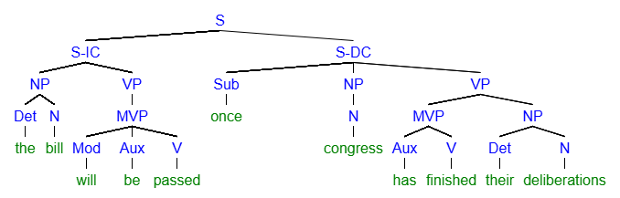
[S [S-IC [NP [Det the] [N bill]] [VP [MVP [Mod will] [Aux be] [V passed]]]] [S-DC [Sub once] [NP [N congress]] [VP [MVP [Aux has] [V finished]] [NP [Det their] [N deliberations]
Question Ten: Please diagram this sentence and answer the questions below. (10 pts)
Sentence: All the horses could have repaired Humpty Dumpty if they had been trying more diligently.
- Identify the aspect of clause one (all the horses could have repaired Humpty Dumpty)
  - Perfect, Progressive, or Perfect Progressive - Perfect
- Identify the tense and aspect of clause two (if they had been trying more diligently)
  - Perfect, Progressive, or Perfect Progressive – Perfect Progressive
  - Past or Present - Past

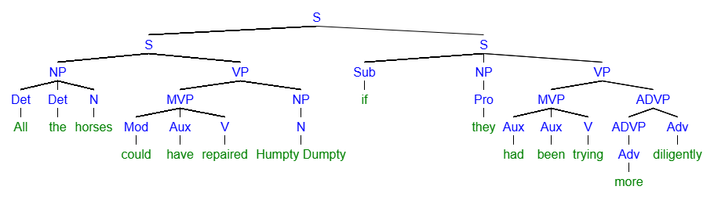
[S [S [NP [Det All] [Det the] [N horses]] [VP [MVP [Mod could] [Aux have] [V repaired]] [NP [N Humpty Dumpty]]]] [S [Sub if] [NP [Pro they]] [VP [MVP [Aux had] [Aux been] [V trying]] [ADVP [ADVP [Adv more]] [Adv diligently
Question Eleven: Please diagram this sentence and answer the questions below. (6 pts)
Sentence: The four noble truths and the eightfold path have been considered fundamental tenets of Buddhism for ages.
- What is the voice of this sentence (Active or passive?)
  - Passive
- What is the tense of this sentence (Past or Present)
  - Present

Sages have considered that stuff (the four noble truths and the eightfold path) fundamental tenets

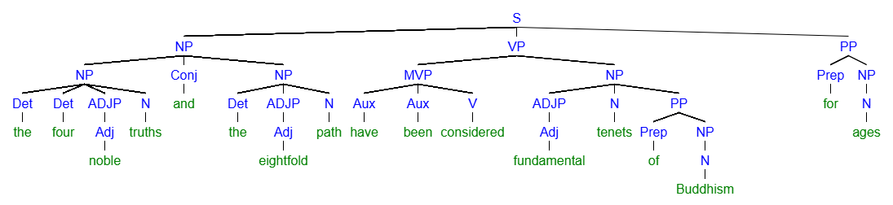
[S [NP [NP [Det the] [Det four] [ADJP [Adj noble]] [N truths]] [Conj and] [NP [Det the] [ADJP [Adj eightfold]] [N path]]] [VP [MVP [Aux have] [Aux been] [V considered]] [NP [ADJP [Adj fundamental]] [N tenets] [PP [Prep of] [NP [N Buddhism]]]]] [PP [Prep for] [NP [N ages]

Section D: Sentence Creation Bonus
For Bonus, please write all the new sentences about a movie, book, or TV show you like. Feel free to reuse the same ideas and characters from the movie, book, or TV show as many times as you like. Feel free to copy from/mirror your earlier sentences in this activity. Be sure to punctuate the sentences correctly!
Name the movie, book or TV show here:___________________
Question Twelve: (2 points)
Write a sentence containing this element
- A passive voice verb phrase in present tense

Question Thirteen: (2 points)
Write a sentence containing this element
- A verb in past perfect progressive

Question Fourteen: (2 points)
- A single verb phrase with both a modal and a progressive aspect verb

